SIMULATION EXPERIMENT – 14

Title
Numerical Simulation and Spectral Analysis of a Microwave Signal for Frequency-Domain Characterization Using Spectrum-Analyzer Concepts

Aim
To generate a 10 GHz amplitude-modulated microwave signal and analyze its carrier, sideband, harmonic and spurious frequency components using frequency-domain spectrum analysis.

Objectives
- To generate a 10 GHz microwave carrier with amplitude modulation.
- To identify the carrier and upper/lower sideband frequencies from the spectrum.
- To study the effect of modulation index on the sideband amplitudes.
- To evaluate the spectral characteristics and signal quality using spectrum-analyzer concepts.

MATLAB Program
The following program performs the simulation for μ = 0.5 and μ = 0.8 and produces the required spectrum plots.
clc;
clear;
close all;

%% =====================================================
% SIMULATION EXPERIMENT - 14
% MICROWAVE SIGNAL SPECTRUM ANALYSIS
%% =====================================================

%% Input Parameters

fc = 10e9; % Carrier frequency = 10 GHz
fm = 0.1e9; % Modulating frequency = 0.1 GHz
A = 1; % Carrier amplitude = 1 V
Fs = 50e9; % Sampling frequency = 50 GHz

mu1 = 0.5; % Modulation index 1
mu2 = 0.8; % Modulation index 2

%% Time parameters

T = 1e-9; % Simulation time
t = 0:1/Fs:T-1/Fs;

N = length(t);

%% =====================================================
% CASE 1 : MODULATION INDEX = 0.5
%% =====================================================

mu = mu1;

% AM signal
s1 = A*(1 + mu*cos(2*pi*fm*t)) .* ...
cos(2*pi*fc*t);

%% FFT

S1 = fft(s1);

S1 = abs(S1)/N;

% Single-sided spectrum
S1 = S1(1:floor(N/2));

f = (0:floor(N/2)-1)*(Fs/N);

% Convert magnitude to dB
S1_dB = 20*log10(S1 + 1e-12);

%% =====================================================
% CASE 2 : MODULATION INDEX = 0.8
%% =====================================================

mu = mu2;

% AM signal
s2 = A*(1 + mu*cos(2*pi*fm*t)) .* ...
cos(2*pi*fc*t);

%% FFT

S2 = fft(s2);

S2 = abs(S2)/N;

S2 = S2(1:floor(N/2));

S2_dB = 20*log10(S2 + 1e-12);

%% =====================================================
% THEORETICAL FREQUENCIES
%% =====================================================

fLSB = fc - fm;
fUSB = fc + fm;

fH2 = 2*fc;

fprintf('\n============================================\n');
fprintf('MICROWAVE SPECTRUM ANALYSIS\n');
fprintf('============================================\n');

fprintf('Carrier Frequency = %.2f GHz\n',fc/1e9);
fprintf('Modulating Frequency = %.2f GHz\n',fm/1e9);
fprintf('Sampling Frequency = %.2f GHz\n',Fs/1e9);

fprintf('\nTheoretical Frequencies:\n');

fprintf('Carrier = %.2f GHz\n',fc/1e9);
fprintf('Lower Sideband = %.2f GHz\n',fLSB/1e9);
fprintf('Upper Sideband = %.2f GHz\n',fUSB/1e9);

fprintf('2nd Harmonic = %.2f GHz\n',fH2/1e9);

%% =====================================================
% FIND SPECTRUM VALUES NEAR REQUIRED FREQUENCIES
%% =====================================================

[~,idxC] = min(abs(f-fc));
[~,idxL] = min(abs(f-fLSB));
[~,idxU] = min(abs(f-fUSB));

Pc1 = S1_dB(idxC);
PL1 = S1_dB(idxL);
PU1 = S1_dB(idxU);

Pc2 = S2_dB(idxC);
PL2 = S2_dB(idxL);
PU2 = S2_dB(idxU);

%% =====================================================
% SIDE BAND LEVEL RELATIVE TO CARRIER
%% =====================================================

LSB_dBc_1 = PL1 - Pc1;
USB_dBc_1 = PU1 - Pc1;

LSB_dBc_2 = PL2 - Pc2;
USB_dBc_2 = PU2 - Pc2;

%% =====================================================
% OUTPUT RESULTS
%% =====================================================

fprintf('\n============================================\n');
fprintf('RESULTS FOR MU = 0.5\n');
fprintf('============================================\n');

fprintf('Carrier Level = %.2f dB\n',Pc1);
fprintf('LSB Level = %.2f dB\n',PL1);
fprintf('USB Level = %.2f dB\n',PU1);

fprintf('LSB Relative Level = %.2f dBc\n',LSB_dBc_1);
fprintf('USB Relative Level = %.2f dBc\n',USB_dBc_1);

fprintf('\n============================================\n');
fprintf('RESULTS FOR MU = 0.8\n');
fprintf('============================================\n');

fprintf('Carrier Level = %.2f dB\n',Pc2);
fprintf('LSB Level = %.2f dB\n',PL2);
fprintf('USB Level = %.2f dB\n',PU2);

fprintf('LSB Relative Level = %.2f dBc\n',LSB_dBc_2);
fprintf('USB Relative Level = %.2f dBc\n',USB_dBc_2);

%% =====================================================
% THEORETICAL AMPLITUDE RELATION
%% =====================================================

% For standard AM:
% Carrier amplitude = A
% Each sideband amplitude = mu*A/2

SB1 = mu1*A/2;
SB2 = mu2*A/2;

fprintf('\n============================================\n');
fprintf('THEORETICAL AMPLITUDE VALUES\n');
fprintf('============================================\n');

fprintf('For mu = 0.5:\n');
fprintf('Carrier amplitude = %.2f V\n',A);
fprintf('Each sideband amplitude = %.2f V\n',SB1);

fprintf('\nFor mu = 0.8:\n');
fprintf('Carrier amplitude = %.2f V\n',A);
fprintf('Each sideband amplitude = %.2f V\n',SB2);

%% =====================================================
% FREQUENCY ERROR
%% =====================================================

% The FFT frequency locations are obtained from the
% nearest frequency bins.

fCarrier_sim = f(idxC);
fLSB_sim = f(idxL);
fUSB_sim = f(idxU);

errC = abs(fCarrier_sim-fc)/fc*100;
errL = abs(fLSB_sim-fLSB)/fLSB*100;
errU = abs(fUSB_sim-fUSB)/fUSB*100;

fprintf('\n============================================\n');
fprintf('FREQUENCY DEVIATION\n');
fprintf('============================================\n');

fprintf('Carrier deviation = %.4f %%\n',errC);
fprintf('LSB deviation = %.4f %%\n',errL);
fprintf('USB deviation = %.4f %%\n',errU);

%% =====================================================
% SPECTRUM PLOT FOR MU = 0.5
%% =====================================================

figure;

plot(f/1e9,S1_dB,'LineWidth',1.5);

hold on;

xline(fc/1e9,'--');
xline(fLSB/1e9,'--');
xline(fUSB/1e9,'--');

grid on;

xlim([9.5 10.5]);

xlabel('Frequency (GHz)');
ylabel('Magnitude (dB)');

title('Microwave Spectrum for AM Signal - \mu = 0.5');

legend('Spectrum','Carrier 10 GHz',...
'LSB 9.9 GHz','USB 10.1 GHz');

%% =====================================================
% SPECTRUM PLOT FOR MU = 0.8
%% =====================================================

figure;

plot(f/1e9,S2_dB,'LineWidth',1.5);

hold on;

xline(fc/1e9,'--');
xline(fLSB/1e9,'--');
xline(fUSB/1e9,'--');

grid on;

xlim([9.5 10.5]);

xlabel('Frequency (GHz)');
ylabel('Magnitude (dB)');

title('Microwave Spectrum for AM Signal - \mu = 0.8');

legend('Spectrum','Carrier 10 GHz',...
'LSB 9.9 GHz','USB 10.1 GHz');

%% =====================================================
% COMPARISON OF MODULATION INDEX
%% =====================================================

figure;

plot(f/1e9,S1_dB,'LineWidth',1.5);

hold on;

plot(f/1e9,S2_dB,'LineWidth',1.5);

grid on;

xlim([9.5 10.5]);

xlabel('Frequency (GHz)');
ylabel('Magnitude (dB)');

title('Effect of Modulation Index on Microwave Spectrum');

legend('\mu = 0.5','\mu = 0.8');

%% =====================================================
% SIDE-BAND LEVEL COMPARISON
%% =====================================================

mu_values = [0.5 0.8];

sideband_relative = ...
20*log10(mu_values/2);

figure;

bar(mu_values,sideband_relative);

grid on;

xlabel('Modulation Index (\mu)');
ylabel('Sideband Level Relative to Carrier (dBc)');

title('Effect of Modulation Index on Sideband Level');

%% =====================================================
% FINAL RESULT
%% =====================================================

fprintf('\n============================================\n');
fprintf('EXPERIMENT COMPLETED SUCCESSFULLY\n');
fprintf('============================================\n');

fprintf('Carrier frequency = %.2f GHz\n',fc/1e9);
fprintf('Lower sideband = %.2f GHz\n',fLSB/1e9);
fprintf('Upper sideband = %.2f GHz\n',fUSB/1e9);

fprintf('Sideband level increases when modulation\n');
fprintf('index is increased from 0.5 to 0.8.\n');

Output

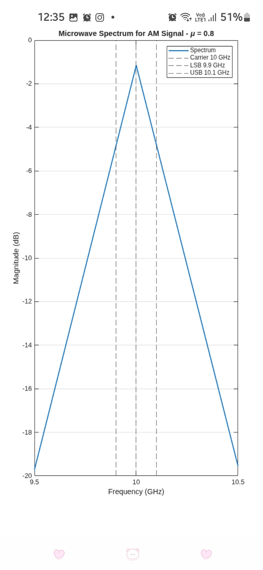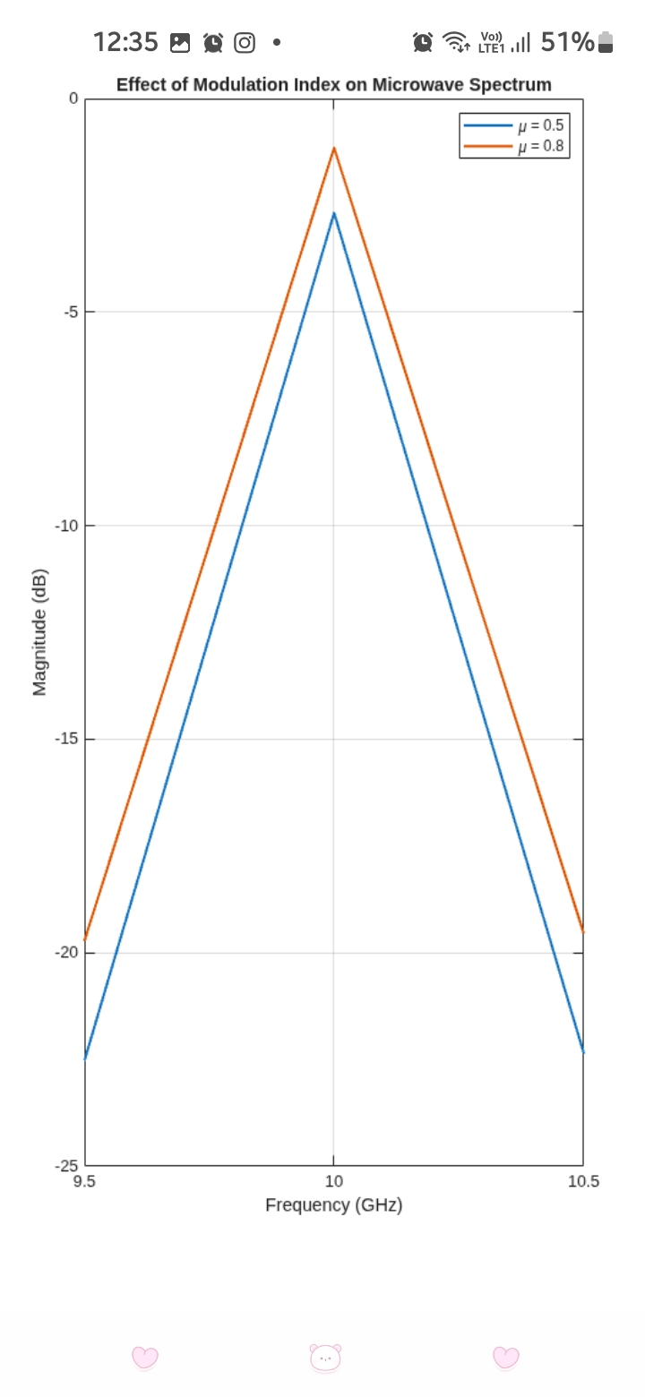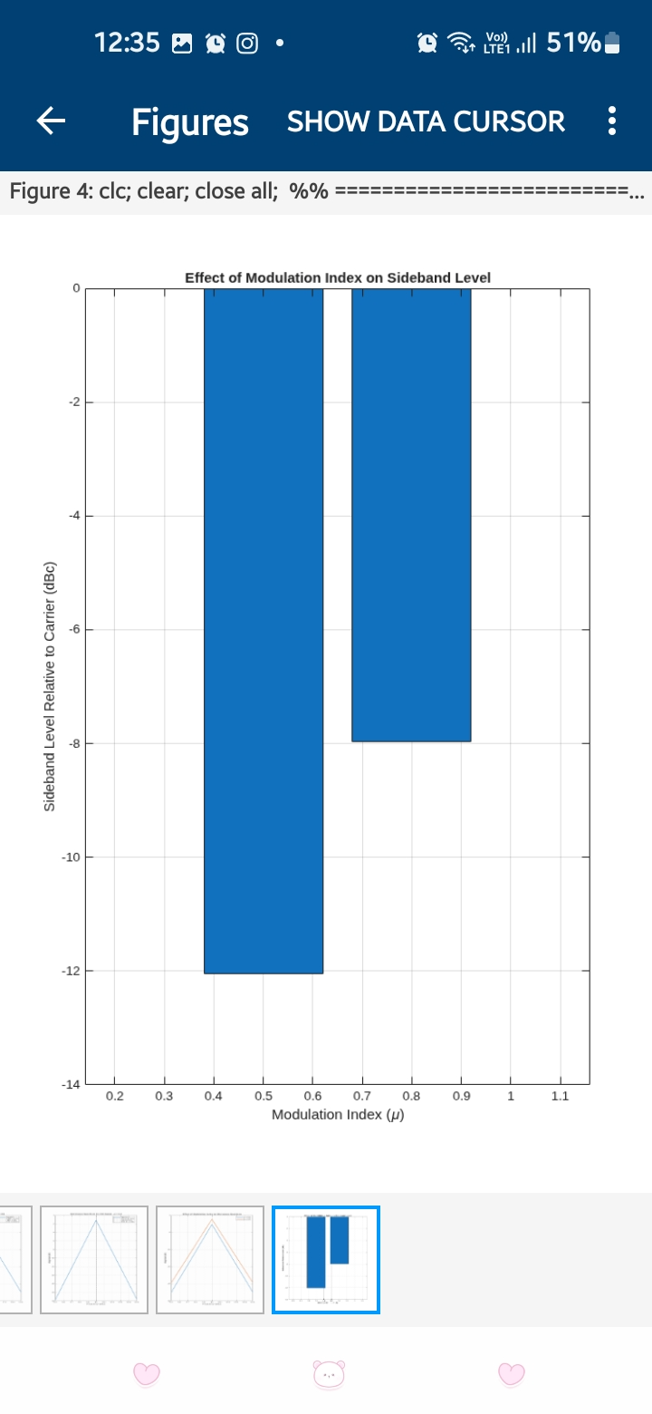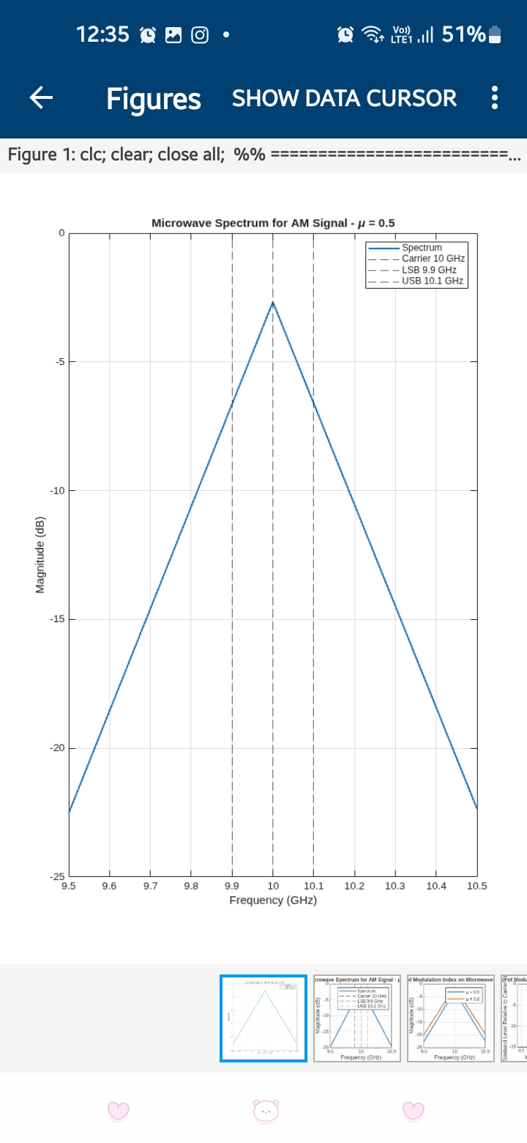

Reflection
The experiment helped in understanding the frequency-domain behavior of a microwave AM signal. The carrier was observed at 10 GHz and the sidebands were identified at 9.9 GHz and 10.1 GHz. Increasing the modulation index increased the sideband amplitudes and spectral occupancy.

Result
The 10 GHz microwave AM signal was successfully generated and analyzed using MATLAB spectrum-analysis concepts. The simulated carrier and sideband frequencies agreed with the theoretical values. The effect of increasing the modulation index from 0.5 to 0.8 was successfully verified, showing increased sideband strength and spectral occupancy.

